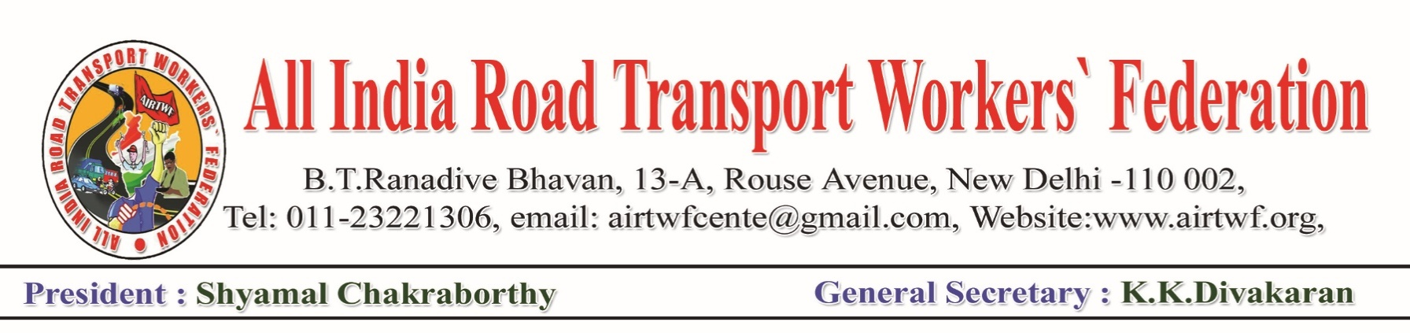
Press Release: Date:29-06-2020

All India Road Transport Workers’ Federation extends all out support and solidarity to the Coal Workers Strike which commences from 02nd July against the retrograde policies of the union Government to privatise the Coal Mines. AIRTWF appreciates all the Unions and Federations for the joint strike call in the industry against the ploicies of the Government. AIRTWF appeals to all the affiliated Unions/Federations to organise solidarity actions in support of the strike duly following the COVID protocals.

The decision of the Government to privatise Coal Mines is anti national and will seriously affect our energy and other sectors. The Union Government is talking at length about “Atma Nirbhar/India’s Self Reliance” and in practice doing in the oppositionn direction to throw the nation to depend on MNCs and other Giant Corporations. AIRTWF demands the Union Government to withdraw forthwith its retrograde policies and discuss with the Unions/Federations in the industry.

(K.K.DIVAKARAN)
General Secretary

