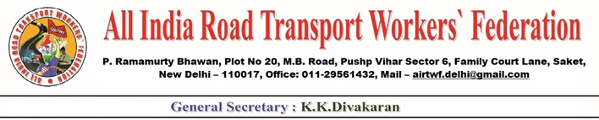
For Publication: Date: 14-12-2020
Express solidarity to Peasants Struggle & Contribute Solidarity fund
All India Road Transport Workers’ Federation Calls upon all its State Units and Federations/Unions to collect Solidarity Fund to the Struggling Farmers on an emergency basis.
AIRTWF appeals to J&K, Himachal Pradesh, Rajasthan, Punjab and Haryana state Units to organize solidarity demonstrations on 17-12-2020 at TIKIRI BOARDER and SINDHU BOARDER.
AIRTWF hails the heroic and historic struggle of the Farmers against the retrograde Agricultural Laws and the Electricity Privatisation Bill 2020. AIRTWF Whole heartedly supports the just and genuine demands of the farmers. It demands the Union Government to repeal the draconian Agricultural Laws and the Electricity Privatisation Bill 2020 forthwith.
The agricultural laws passed by the Parliament are not only harmful to farmers but the entire people will face severe food security problem. The privatization of electricity will lead to heaviest burden on the consumers. In essence, the farmers agitation is not for the benefit of the farmers alone. They are fighting for the people and the nation as a whole.
(K.K. DIVAKARAN)
General Secretary

