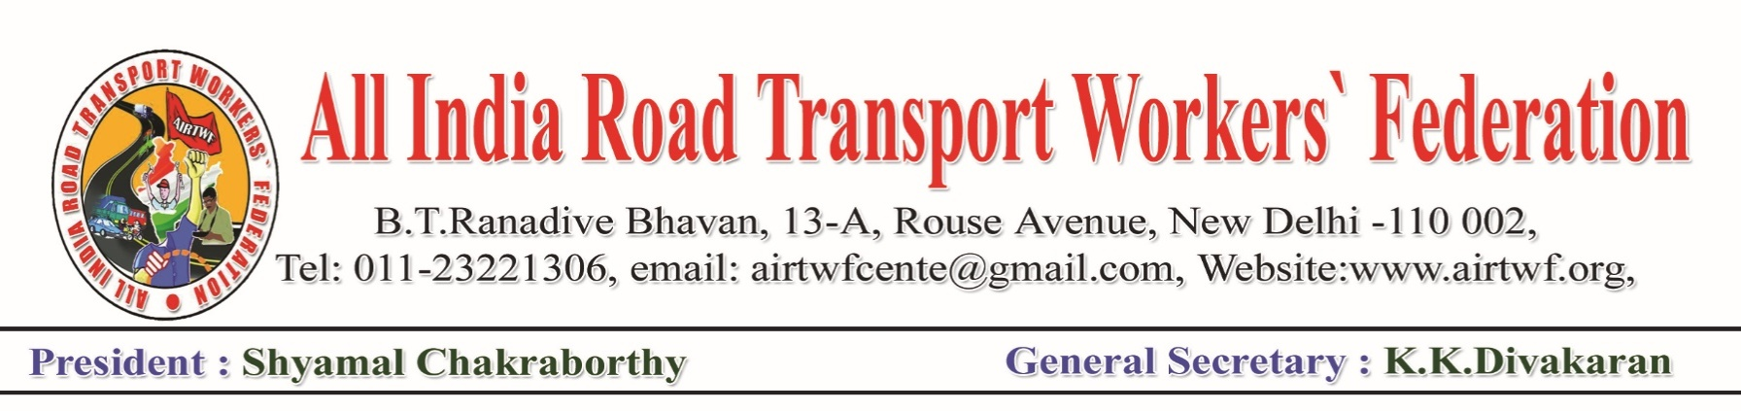
For Publication: 21-03-2020

All India Road Transport Workers’ Federation is very much worried with the pandemic of Corona Virus which severely hit the economy. Millions of self employed and unorganised workers in the transport sector along with other sectors of the workers become the worst affected with the pandemic. Kerala State government has come forwarward and announced several economic supporting measures to the people at large. AIRTWF appeals to the Union Government and the State Governments to extend support by supplying essential commodities at free of cost to the poor workers. It has written a letter to Shri.Nitin Gadkari, the Minister of Road Transport and Highways to this effect.

The Transport workers ought to be on road inspite of the odd conditions. Particularly the Auto Rickshaw, Taxi, Private and State Transport Bus workers are transporting people knowing the danger that they may also be affected by Corona Virus. These workers are to be supplied with good quality of masks, sanitisers etc at free of cost. It is reported in the media that almoast 70% of the trucks re off the road due to thereduced productions of goods and transportation. A good number of these unorganised transport workers are not getting any earnings during this Corona Virus period. All of them are depending on their daily earnings. When they could not get any earnings their family virtually suffers with starvation. Hence it is most essential on the part of the Government to take suitable steps for their rescue.

Ironically, the Honourable Prime Minister kept mum on this vital issue of extending financial support in his addres to the nation on 19-03-2020 except giving advises to the people who are really suffering and worriewd about their livelyhood. This proves the gross negligence/arrogance of the Government towards the peole of the nation particularly the sufferings of the unorganised workers.
AIRTWF demands the union Government to take immediate steps to help the unorganised workers.

(K.K.DIVAKARAN)
General Secretary

