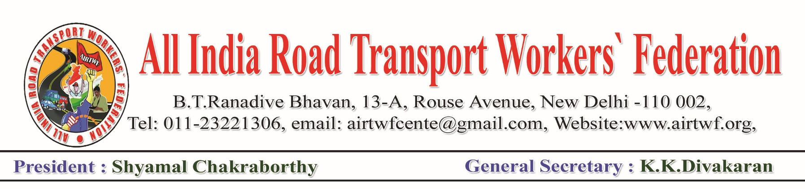
To, Dated: 29-06-2020
Shri. Uddhav Balasaheb Thackeray Ji,
Honourable Chief Minister,
Government of Maharashtra,
MUMBAI.
Respected Sir,
Sub: COVID 19- Lockdown- Certain problems faced by the workers of
BEST-Request for your intervention to settle the problems-
Regarding.

We would like to draw your kind attention to the problems faced by the workers
of BEST with a request for your intervention to redress the following grievances.

We are aware of the serious situation of COVID in the state of Maharashtra, particularly in Mumbai City and sincere and serious efforts of your Government to contain. We assure you that all the Transport Workers will whole heartedly support the efforts of the government to contain COVID and to help the people.
- We came to know that around 55 workers/Supervisors/Officers have died due to COVID-19. But the family members of the deceased employees did not get any monetary benefits. Rs.50 Lakhs Insurance Scheme announced by the Central Government shall be made applicable to the deceased employees of BEST.
- Personnel Protective Equipment suitable to the Conductors and Drivers and sanitizer shall be supplied to all who are booked to duty.
- We came to know that some employees are served with Dismissal orders during the Lockdown period. All such orders shall be withdrawn forthwith. Similarly, the Charge Sheets and other disciplinary actions during the COVID & Lockdown period shall be withdrawn.
We hope your kind authority will respond positively and necessary instructions may be issued.
(K.K.DIVAKARAN)
General Secretary

