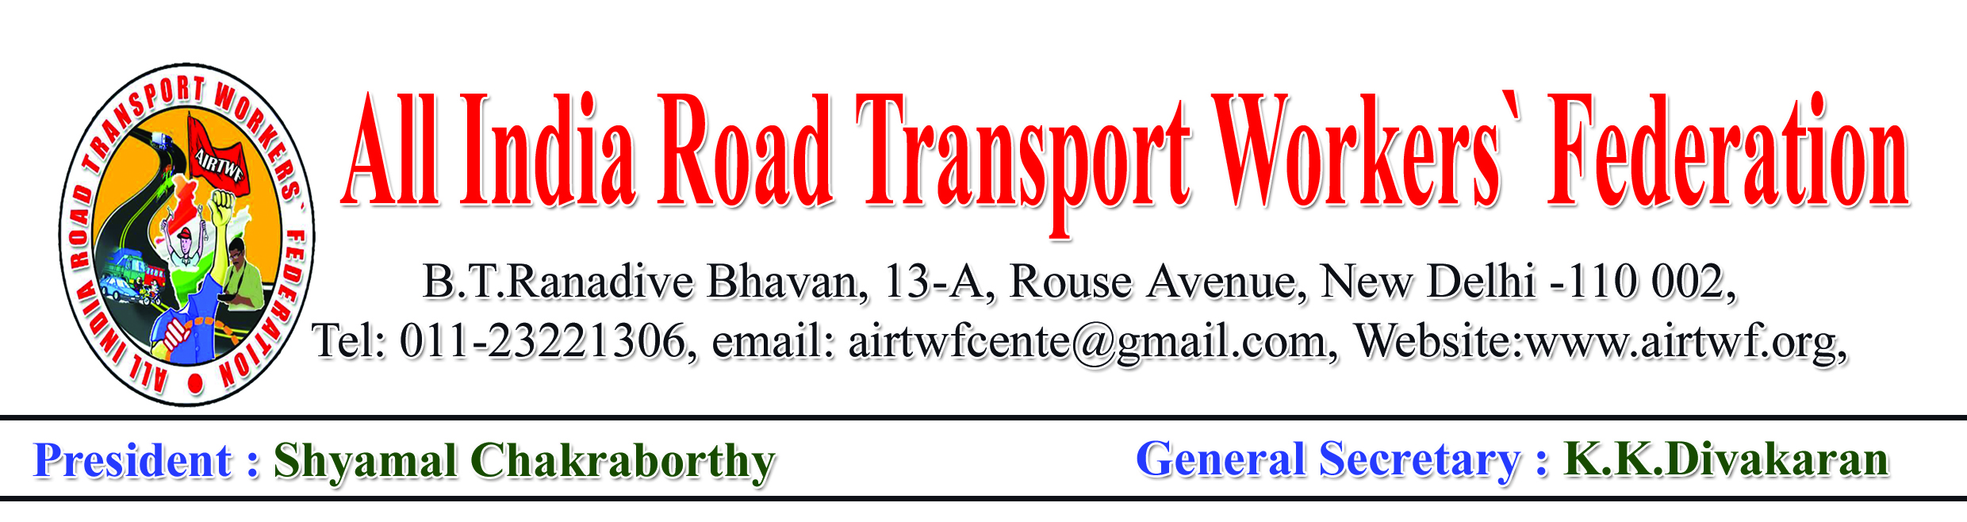
To, Dt: 26-02-2018
The Hon’ble Lt.Governor,
Andaman Nicobar Islands,
Port Blair.
Respected sir,
Sub:- Your intervention to settle the demands of Govt Transport Depart-
ment Employees – Requested – Reg
Ref: 1. Strike Notice served by the Union, dt.05-02-2018
2. Reply by the Authorities, dt. 19-02-2018
3. Minutes of the meeting, dt. 20-02-2018
I would like to draw your attention to the strike notice under reference 1 cited and request your good self to please intervene and direct the concerned Authorities to settle the demands amicably.
It is submitted that the Authorities have given a reply vide under reference 2nd cited. No proposal for the redresal of the demands is given. There after a joint meeting was called on 22-02-2018 vide under reference 3rd cited. In that meeting the Authorities appealed for two weeks time which was accepted by the union.
In fact the demands are long pending and some are agreed also. But even after repeated request by the union they were not implemented. It is nothing but testing the patience of the Union and the workers.
In the light of the above your good self is requested to intervene and direct the concerned Authorities to settle the just and genuine demands of the workers.
Yours sincerely
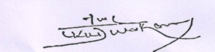
K.K.DIVAKARAN
General Secretary

