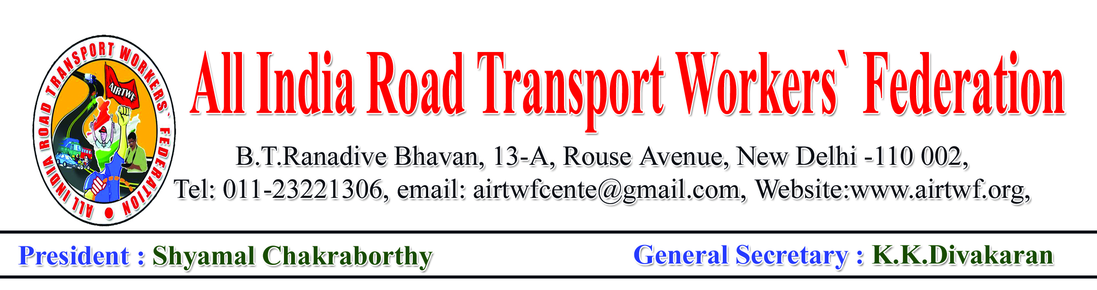
To, Dated:10-01-2019
The General Manager,
BEST,
MUMBAI.

Dear Sir,

Sub: Requested to withdraw the illegal letter under reference forth with.
Ref: Notice issued on Mr.DevendraSharadchandraJavkar by the Ag.
SeniorPersonnel Manager(Welfare) videLr. No.
Sr.PM/SWO/Allotment/2019, Dt.08-01-2019.

I would like to draw your attention towards the notice under reference cited. The workers participated in the strike at the call given by several unions in BEST. Further, the All India Co-Ordination Committee of Road Transport Workers’ Organisations have given a call for national strike on 08th& 09th January to save the STUs, the Road Transport sector as a whole and to protect the workers. Accordingly a strike notice was served on the Secretary, Ministry of Road Transport on 22-12-2018.

It is not out of place to mention that it is the right of the workers to go on strike when the demands are not solved after serving the notice under the provisions of ID Act. Terming the strike as illegal and serving notices to the workers to vacate the quarteris illegal, against the principles of natural Justice and highly condemnable.

You are therefore requested to intervene and cause order for withdrawal of the illegal order under reference cited.

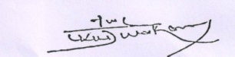

(K.K.DIVAKARAN)
General Secretary, AIRTWF &
Convenor,
All India Co-ordination Committee of
Road Transport Workers’ Organisations

