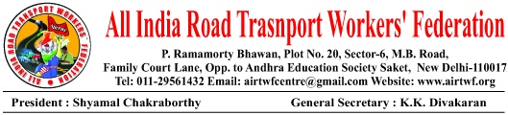

To, Dated: 03-07-2019
Shri.Amarindar Singh Ji,
Hon’ble Chief Minister,
Government of Punjab,
Chandigarh.

Respected Sir,

Sub: Strike by Pun Bus Workers- Requested to intervene and settle the
Issues.

I would like to draw your kind attention to the strike by Pun Bus workers.
They went on strike from early hours of 02-07-2019 after all attempts to settle the issues through peaceful negotiations and by issuing of strike notice are failed.

It is submitted that the two main demands are 1) Regularization of the services of contract workers who are even working since two decades. 2) Implementation of the Hon’ble Supreme Court Judgment on “Equal Work-Equal Pay”. These two are most genuine, Justified and pending since long time.

The demand for regularization of their services is genuine and justifiable. The
Work of a permanent Conductor/Driver/Mechanic etc to the work of Contract
Conductor/Driver/Mechanic is same. Disparity among wages is illegal. The Hon’ble
Supreme Court also ruled it as an illegal and order for “Equal Work-Equal Pay” almost
two years back. Ironically yet it is not being implemented.

Hence All India Road Transport Workers’ Federation appeals to your kind
authority to intervene and settle the just demands of the Pun Bus Workers forthwith.

Yours sincerely
(K.K.DIVAKARAN)
General Secretary

